Assignment 1: Sprint on One Dataset Each
Name: Karu Skipper
ID: 300417869

2.1 Core: Investigate Basic Use of The Different Tribes of AI [40 marks]

For this assignment I will be classifying the sona.all-data file (nomial & converted to csv).
a)
Multilayer Perceptron
Tool: Weka (10 folds cross validation)
Time taken to build model: 11.36 seconds

Correctly Classified Instances 173 83.5749 %
Incorrectly Classified Instances 34 16.4251 %
Kappa statistic 0.6693
Mean absolute error 0.1727
Root mean squared error 0.375
Relative absolute error 34.7204 %
Root relative squared error 75.1811 %
Total Number of Instances 207

TP Rate FP Rate Precision Recall F-Measure ROC Area Class
0.813 0.144 0.83 0.813 0.821 0.895 R
0.856 0.188 0.841 0.856 0.848 0.895 M

Weighted Avg. 0.836 0.167 0.836 0.836 0.836 0.895

a b <-- classified as
78 18 | a = R
16 95 | b = M

DecisionTree(J48)
Tool: Weka (10 folds cross validation)
Size of the tree : 35
Correctly Classified Instances 154 74.3961 %
Incorrectly Classified Instances 53 25.6039 %
Kappa statistic 0.4812
Mean absolute error 0.2663
Root mean squared error 0.4969
Relative absolute error 53.5308 %
Root relative squared error 99.6378 %
Total Number of Instances 207

TP Rate FP Rate Precision Recall F-Measure ROC Area Class
0.667 0.189 0.753 0.667 0.707 0.731 R
0.811 0.333 0.738 0.811 0.773 0.731 M

Weighted Avg. 0.744 0.266 0.745 0.744 0.742 0.731

a b <-- classified as
64 32 | a = R
21 90 | b = M

Naive Bayes
Tool: Weka (10 folds cross validation)
Correctly Classified Instances 139 67.1498 %
Incorrectly Classified Instances 68 32.8502 %
Kappa statistic 0.3523
Mean absolute error 0.321
Root mean squared error 0.539
Relative absolute error 64.5225 %
Root relative squared error 108.0758 %
Total Number of Instances 207

TP Rate FP Rate Precision Recall F-Measure ROC Area Class
0.792 0.432 0.613 0.792 0.691 0.796 R
0.568 0.208 0.759 0.568 0.649 0.796 M
Weighted Avg. 0.671 0.312 0.691 0.671 0.669 0.796

a b <-- classified as
76 20 | a = R
48 63 | b = M

K-Nearest-Neighbour (Ibk)
Tool: Weka (10 folds cross validation)
K = 3
Correctly Classified Instances 177 85.5072 %
Incorrectly Classified Instances 30 14.4928 %
Kappa statistic 0.707
Mean absolute error 0.1574
Root mean squared error 0.3216
Relative absolute error 31.6458 %
Root relative squared error 64.4782 %
Total Number of Instances 207

TP Rate FP Rate Precision Recall F-Measure ROC Area Class
0.802 0.099 0.875 0.802 0.837 0.93 R
0.901 0.198 0.84 0.901 0.87 0.93 M

Weighted Avg. 0.855 0.152 0.856 0.855 0.854 0.93

a b <-- classified as
77 19 | a = R
11 100 | b = M

b)
Results in summary:
To begin, the highest accuracy result was K-Nearest-Neighbour (with k set to 3 the result was 85.5072 %). Here I experimented with different k values but found the best accuracy/highest correctly classified instances was when k = 3. The multilayer perceptron was running with 3 hidden layers and reieved the above accuracy of (83.5749 %), as I increased it to 8, I recieved a higher classification accuracy (85.0242 %). I kept the learning rate the same at 0.3 and momentum at 0.2 (go into detail about this). This gave me the second highest accuracy of the 4 techniques.

Things to note about the results:
We can not conclude that k-nearest-neighbour has the best accuracy based off 1 data set with certain given parameters. Instead, we can assume that the highest accuracy algorithms are similiar in classification and their parameters can be easily changed to produce similiar results.
Although we make this assumption, algorithms such as Naive Bayes are less likely to be suited to this data set as the classes must be conditionally independant.

The 5 tribes of AI diagram, this will be helpful for understand the next section:
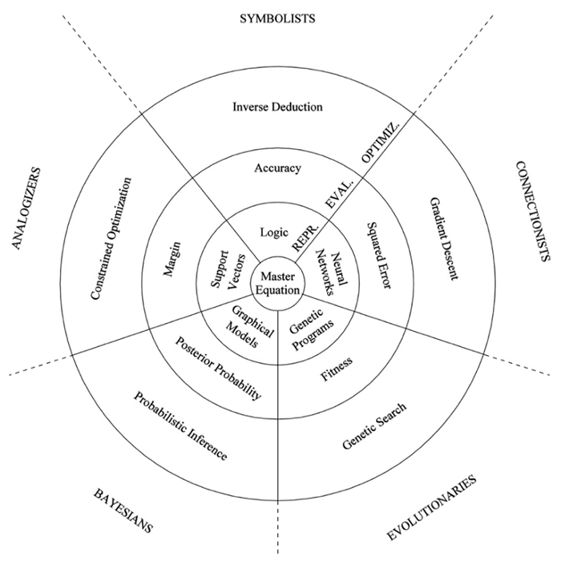
Multilayer Perceptron (Connectionist)
General description:
A multilayer perceptron is a feedforward artificial neural network which generates a set of outputs from a set of inputs. A multilayer perceptron consists of at least three layers of nodes: an input layer, a hidden layer and an output layer. Except for the input nodes, each node is a neuron that uses a nonlinear activation function.

Representation:
A multilayer perceptrons is used to identify small linearly separable sections of the inputs. Outputs of the perceptrons are combined into another perceptron to produce the final output. In this problem I used the 2 classes (rocks and mines) to be classified through the 3 layer MLP (changed to 8 layer for higher accuracy later on). This is represented as a Neural Network, which is an aftificial representation of the human brain and it’s neuralogical connections. Hence the name “connectionist.”

Evaluation:
Stopping criteria is using in MLP when a certain number of epochs is reached. In a MLP we use stopping criteria such as epochs, validation sets or thresholds to complete the trained program. Most importantly the Mean Squared Error (MSE). Which is the simplilist most common used
error function in Neural Networks used for regression. So the way a neural network works is, when it predicts some value for an output, it compares it with the actual output and sends the error back to the nodes. This process is called backpropagation. Now, mean squared error is just one way to calculate the error, there are many other ways to calculate error. We must set these thresholds, errors and epochs to an appropriate number relative to our program.

Optimization
Because of the validation set described earlier it prevented overfitting of our evaluated result. This meant we recieved a more accurate result. Optimizing when/how we should approach implementing this on the training set is especially important for the best performance of the MLP.

Gradient Descent is one of the most popular and widely used algorithms for training a machine learning model. Machine learning models typically have parameters (weights and biases) and a cost function to evaluate how good a particular set of parameters are. To optimize this model, we must try and get the best performance through altering these parameters.

Here is an example below of an MLP, where in our data set, the input nodes are attributes and the output(s) are the desired classes. I originally had a GUI screenshot of the MLP but unfortuntunately the amount of input nodes went off the screen and I was unable to resize it.

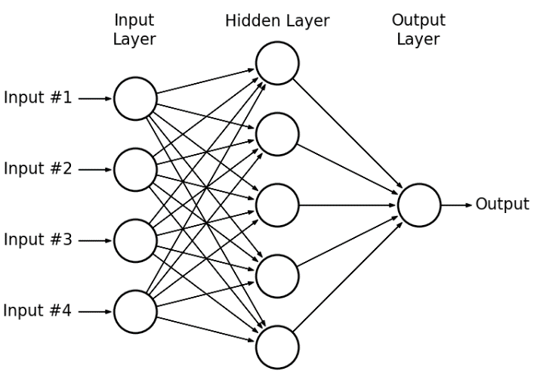
DecisionTree(J48 Symbolist)
General description:
Tree based learning algorithms are considered to be one of the best and mostly used supervised learning methods. Unlike linear models, they map non-linear relationships quite well. They are adaptable at solving any kind of problem at hand. Decision Tree algorithms are referred to as CART(Classification and Regression Trees).

Representation:
Decision Trees perform well when classifying or solving regression problems. In this case I was classifying numerical data which also works quite well on this data set. The Decision Tree constructs its self using a root node and further decision nodes. From these further decision nodes the classes (rocks and mines) are classified into either a leaf node or a subtree. Where it continues this process until the final leaf node. This is a logical representation type algorithm, which means it draws conclusions based off various conditions.

Evaluation:
Decision Trees make ‘decisions’ based of an impurity measure to evaluate a result. This is usally the case for tree structures like the J48. In this case we will be basing our classification using this impurity measure to figure out whether the class is a ‘rock’ or ‘mine.’ The tree seperates its self into smaller sub-trees based off impurity until its reached its final leaf node. This evaluation method uses an accuracy measure in its evaluations.

Optimization
Pruning is a method of optimizing your decision tree and is the inverse of splitting a tree. To stop the tree from overfitting we will prune the tree to reduce the large space and complexity affecting our results. This speeds up the calculations in our decision tree and allows room for analysing our results a lot clearer. Pruning can reduce accuracy but this is a given when removing/reducing branches to make our processing speed faster. For Symbolists, instead of the classical model of starting with a premise and looking for the conclusions, there is a method called inverse deduction that starts with a set of premises and conclusions and works backward to fill in the gaps.

NaiveBayes(Bayesian)
General description:
Naive Bayes is one of the techniques from the Bayesian AI tribe. Naive Bayes using probability in its technique to compute data. I have attached the Bayes rule below which the tree uses to find the highest probability. Naive Bayes classifiers are highly scalable, requiring a number of parameters linear in the number of variables (features/predictors) in a learning problem. Commonly used in Machine Learning, Naive Bayes is a collection of classification algorithms based on Bayes Theorem.

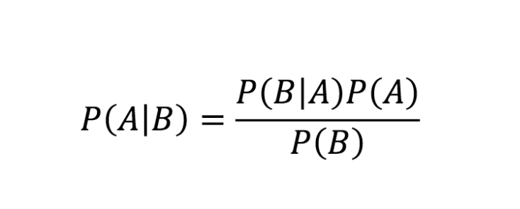

Representation:
Bayes Rule assumes independance of each feature, which can result/distrupt the algorithm. Naive Bayes algorithms are mostly used in analysis, spam and filtering. Bayes Naive is represented in a probabilistic Graphical Model. (Tree Based format).

Evaluation:
The evaluation method that that Naive Bayes uses in pobability, the higher the probability the better the performance is. Naive Bayes will generate a random function because the function is originally unknown, the result of this is Posterior Probability.

Optimization
Unlike Decision Trees, you cannot prune the tree as this will result in class (data) loss and inaccuracy. Instead we are more reliant on changing and refining our data. This includes features optimization (depending on the dataset). We need to find a middle ground where this is most efficient. We can also adjust the classifiers tunable parameters to increase and optimize accuracy. If you have a large dataset it is better to condense/use a smaller one because of the Naive Bayes calculations for probability. More calculations mean more memory ususage and longer to make assumptions based off this. The actual calculations of this is called Probabilistic inference, and it how Bayesian tribes optimize the model.

K-NearestNeighbour(Analogizer)
General description:
KNN is a simple supervised learning technique, used for classifying data. KNN uses a given nodes nearest neighbour based off the k value you set. This can drastically change your results, as it uses this method to classify its data. KNN specially uses the euclidean distance to solve its nearest neighbours. From this it can categorise it into classes based of this distance, it repeats this process for every instance in the data set.

Representation:
The algorithm doesnt learn a model it uses instance based learning, (it uses instances in the training set). KNN’s key feature is the k value, as described earlier. It is the most important part for deciding and refining accuracy. As we increase this k value the systems memory increases significantly as we are making multiple comparisons. In this case I maxed out at k = 8 without losing any accuracy. Past this point it started merging categories and resulting in a less accurate result. KNN uses support vectors as a way of representation.

Evaluation:
KNN belongs to Analogizers because it is instance-based learning. It uses a method of finding the distances from 1 instance to another as its evaluation method. The most popular choice is the euclidean distance for solving but there are various ways and alterations to the euclidean distance but the one below is the most used.
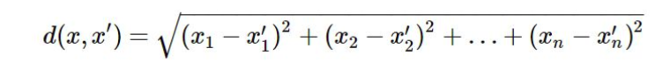
Optimization
For KNN, it is important to pick a suitable value for K. When K is small, says 1 we are restraining, and our classifier cannot consider the overall distribution. On the other hand, it will provide the most flexible fit, which will provide low bias but a very large variance. Another method is to perform a k-fold-cross validation (which I did) that in summary gets the most accurate attributes to classify. In this case I used k =10 as I didnt want to overfit the data. This is called contrained optimization.

I have attacted a good example of KNN and the k value that is relative to our data set, (substituting Class A for Mines and Class B for Rocks)

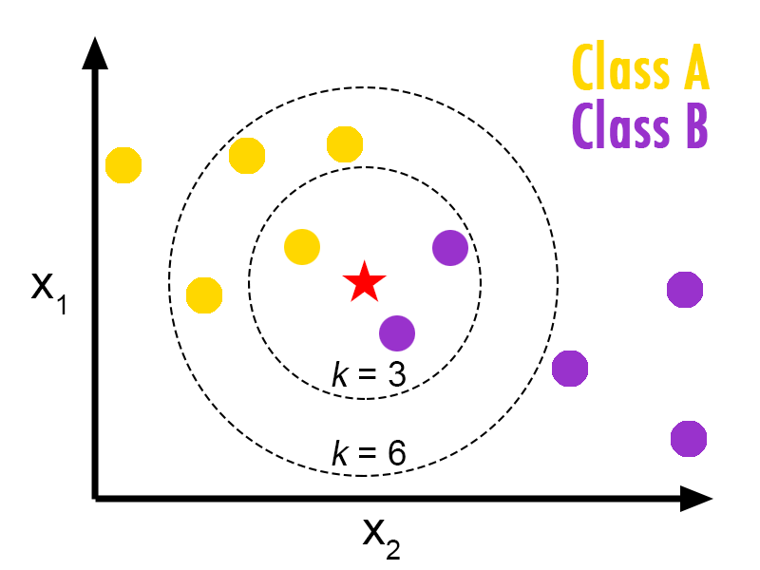

c)
Differences in each technique based off the dataset
To refresh, the dataset I am using is nomial and contains two main classes, ‘rocks’ and ‘mines.’ This means some classfiying techniques may be more likely to perform well than others. This is mainly because of the structure of these individual techniques. I will be covering this later on, comparing each technique and how it operates based off the ‘rock and mines’ dataset.

One of the reasons most of my techniques performed so well was the layout and strucutre of the given dataset. Each line of the file represented a class and was labelled accordingly (R or M). With all given attributes of that class also provided. If we were given a class without such information, it is likely our results and assumptions may differ.

Below I have compared the differences of each technique based off the dataset:

Multilayer Perceptron :

How does it perform with the given dataset compared to other techniques?
The MLP correctly classified 173 instances of the 207, resulting in an 83.5749% accuracy.

Firstly, MLP has many tunable parameters that we can alter to refine our accuracy and produce better results. Although this is true, we cannot apply MLP to all data sets. MLP is great for producing results over a series of epochs, but compared to tehcniques such as Decision Trees, it can become quite complex and time consuming. On this dataset, it produced the best results but suffered serverly in the time complexity compared to other techniques. (Time taken to build model: 11.36 seconds). I ran some extra tests and found that every other tehcnique took an average of around 0 – 1 second to complete its k-fold and evaluation. This is more than 10x slower than any other tehcnique when running on this dataset.

Decision Tree :

How does it perform with the given dataset compared to other techniques?
Decision Trees are a good classifier for numerical data/categorical data and managed to correctly classify 74.3961% of this numerical dataset. There were quite a few options with altering parameters but I decided to keep them at a default state. numFolds(determines the amount of data for reducing error pruning) was left at 3. The size of my tree is ‘35’ because of my minNumObj parameter which alters the depth based off 2 instances per leaf.
This was mostly because the dataset wasn’t too large to classify, after experimenting I found that changes these values has little effect to the results unless drastically changed.

Naive Bayes:
How does it perform with the given dataset compared to other techniques?
As mentioned before, Naive Bayes only evaluate based on probability. Naive Bayes assumes independance of the features, thats why on this dataset it performed poorly compared to others with an accuracy of 67%. Naive Bayes doesn’t work as well on numerical datasets and is more likely to perform well on data sets with categorical characteristics.

K-Nearest-Neighbour:
How does it perform with the given dataset compared to other techniques?
KNN performs well with in this dataset, as it has enough features to classify well. I have set the k value to 3 for this data set. Any larger and there was a significant decrease in accuracy, along with a longer processing time as it has to complete more calculations for its neighbours. Because the dataset is relatively small, I have defaulted it at k = 3.

2.2 Completion 1: Consider a Pipeline for Dataset Processing [20 marks]

Business understanding
(This information was taken directly from the sonar.names file, I found this question was already supplied after short analysis of the file).

Name:
Sonar, rocks vs mines (the sonar.csv we are analysing contains 208 instances)

Summary:
This is the data set used by Gorman and Sejnowski in their study
of the classification of sonar signals using a neural network. The
task is to train a network to discriminate between sonar signals bounced
off a metal cylinder and those bounced off a roughly cylindrical rock.

Source:
The data set was contributed to the benchmark collection by Terry
Sejnowski, now at the Salk Institute and the University of California at
San Deigo. The data set was developed in collaboration with R. Paul
Gorman of Allied-Signal Aerospace Technology Center.

Methodology:
The file "sonar.mines" contains 111 patterns obtained by bouncing sonar
signals off a metal cylinder at various angles and under various
conditions. The file "sonar.rocks" contains 97 patterns obtained from
rocks under similar conditions. The transmitted sonar signal is a
frequency-modulated chirp, rising in frequency. The data set contains
signals obtained from a variety of different aspect angles, spanning 90
degrees for the cylinder and 180 degrees for the rock.

Each pattern is a set of 60 numbers in the range 0.0 to 1.0. Each number
represents the energy within a particular frequency band, integrated over
a certain period of time.
The label associated with each record contains the letter "R" if the object is a rock and "M" if it is a mine (metal cylinder). The numbers in the labels are in increasing order of aspect angle, but they do not encode the angle directly.

Data understanding:

Here are the main pre-processing techniques I have used:

- Data cleansing
- Data editing
- Data reduction
- Data wrangling

As noted previously in question 1, we are sampling 60 numbers (attributes) in the range 0.0 -1, this means that we have an excessive amount of attributes to process considering the datasize of 208 instances. Although this is the case we have quite a good ratio of rock to mine instances but I have still decided to resample the data as this will make our testing more fair, this technique is called data editing. Which involves balancing the instance ratio to make it mroe of a fair test on our data to be processed. (This has been set to 100%).

Another pre-processing technique is data cleansing, which involves removing corrupt or innaccurate instances. After visualising the data in both cluster and bar graph format, I noticed some outliers above the upper-quartile of the data. I refrained from cleansing the data as there was too many attributes and instances to make a fair assumption that I needed to. Lastly, thre data wrangling (data munging) was also not used because there was no need to filter/map the data as the dataset was already in nomial form. Meaning I was able to analyse it straight away without adapting/filtering it again.

Data preparation
In preparation for the data, the pipeline could assist because it increases the number of instructions that can be processed at once. This means that we can apply multiple functions to the dataset at once.

Modelling
The simple pipeline I created suits many of the tribes listed above, although this is the case I tested it on NaiveBayes (the least accurate) and found

Evaluation
This pipeline supports many methods and can accurately evaluate solutions. For example, I ran the pipeline with MLP and it resulted in similiar results. It also completed the k-fold cross and evaluation in around 4 seconds, 7 seconds faster than without one. This is because the pipeline method pre-processes data a lot faster than running an individual test.

Deployment
There was an additional effort to setup and deploy the pipeline, however it offered a visual representation of the process we are undertaking. This meant we were able to implement and refine processes to our pipeline.

Completion 2: Use the pipeline to reevaluate the selected techniques in Part 2.1 used to classify the dataset [20 marks]

Pipeline

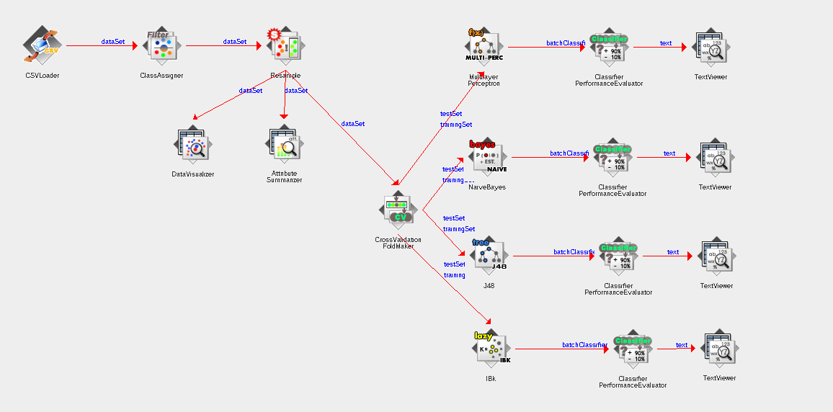
Compare and contrast:
In the naive approach the accuracy was slightly lower because it didn’t have pre-processing techniques I added later in my pipeline approach. The accuracy of the piepline being greater is mainly because I added resmapling of the data, which was not done with the naive approach. If we analyse the screenshot above, we can see I have added a resample before also executing a k-fold cros validation.

Another major difference was the fact we were testing our data using a sprint technique, this means we wern’t including a test set (percentage split in WEKA). This means the data could have been overfit/underfit for the learned classifier.

Lets take an example and analyse the MLP results and compare them. Note I have used the same parameters for each learned MLP classifier(momentum = 0.2, learningRate = 0.3, hidden layers = 3) . Originally I resulted in an accuracy of 83.5749 % before the pipeline, after changing technique I resulted in an improved accuracy 91.3043%. thats around a 7 – 8 % increase. If we take other examples we can see an average increase of around 5 – 6% increase.

This is solely from our pre-processing techniques, that I used and implemented in my pipeline. I am fairly confident that using these pre-processing techniques resulted in the higher accuracy. I believe replication of these results will be possible if we run the learned classifier on another test set.

-- changes in accuracy
-- confidence in results
-- likelyhood of replicating

NaiveBayes
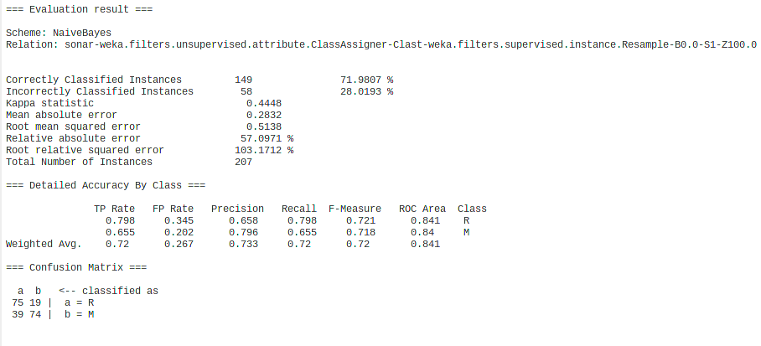

MultilayerPreceptron
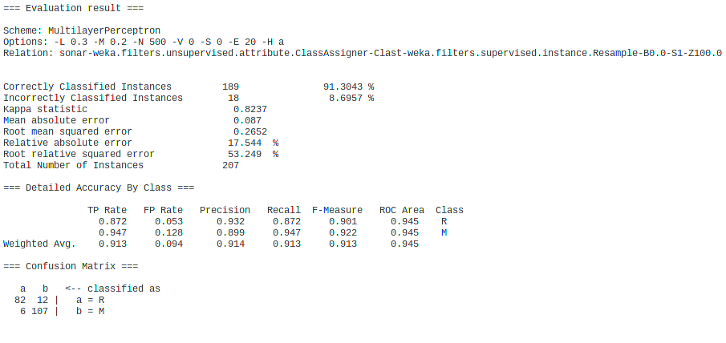

J48

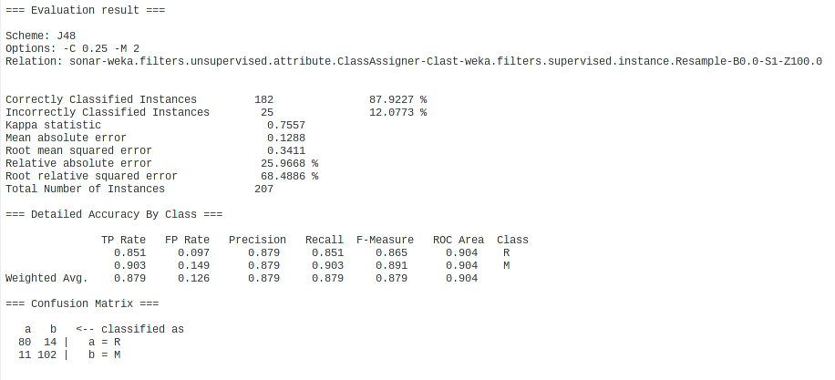

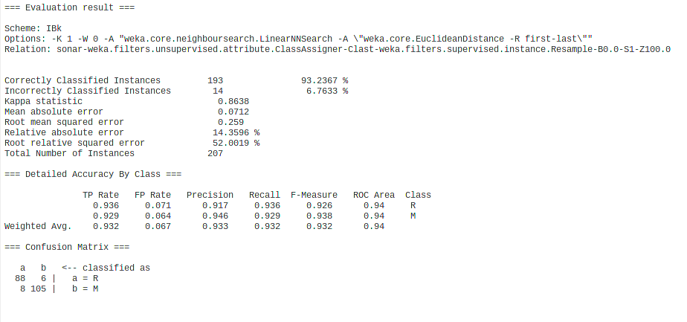
KNN

Report on the data:
Accuracy in terms of the fraction of the test instances that it classified correctly.

2. Report a snapshot of the learned classifiers discovered by your program.
3. Compare the accuracy of your techniques before and after using a data pipeline approach. Please comment on any differences, suggesting reasons. (approximately three paragraphs of text plus figures)

Program | J48 | IBk | MLP | NaiveBayes
Original Accuarcy | 74.3961 % | 85.5072 % | 83.5749 % | 67.1498 %
Pipeline Accuracy | 87.9227 % | 93.2367 % | 91.3043 % | 71.9807 %

Challenge: Use the KEEL to evaluate the Evolutionary Computation tribe on the dataset in Part 2.1 to classify the dataset [20 marks]
1.
- To begin, load the EvolutionaryProgram.xml located in the Assignment1/datafiles/part3/ folder. This should bring up the BioHEL-C evolutionary program I’m using to test the data.

- Located in the Assignment1/datafiles/part3/EvolutionarySonar/results/Vis-Clas-Check/TSTBioHEL-C/ folder there is a file called result0s0.stat where you can access the below results:

- If you were wanting insight on the BioHEL-C classifier, a full background is given when selecting the Vis-Class-Check after loading the EvolutionaryProgram.xml into KEEL.

Raw output of the BioHEL-C classifier:

TEST RESULTS
============
Classifier= .a/sonar/sonar
Fold 0 : CORRECT = 0.7619047619047619 N/C=0.0
Fold 1 : CORRECT = 0.8571428571428572 N/C=0.0
Fold 2 : CORRECT = 0.9047619047619048 N/C=0.0
Fold 3 : CORRECT = 0.7142857142857143 N/C=0.0
Fold 4 : CORRECT = 0.7619047619047619 N/C=0.0
Fold 5 : CORRECT = 0.7619047619047619 N/C=0.0
Fold 6 : CORRECT = 0.6666666666666667 N/C=0.0
Fold 7 : CORRECT = 0.65 N/C=0.0
Fold 8 : CORRECT = 0.7 N/C=0.0
Fold 9 : CORRECT = 0.7 N/C=0.0

Global Classification Error + N/C:
0.2521428571428571

stddev Global Classification Error + N/C:
0.0768310128473352

Correctly classified:
0.7478571428571429

Global N/C:
0.0
Results summary:
The evolutionary program successfully classified 74.79% of the instances in the data set.

2)
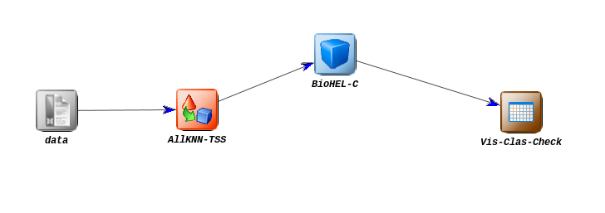

3. Compare the Evolutionary Computation approach with the other AI tribes from earlier parts.

To compare, evolutionary computation and the process of how it works is significantly different to the other AI Tribes. If we check the diagram below, we can see that all tribes are different. To compare the 4 others to this, we can see that the evaluation uses a fitness function.

Evolutionary programs also have

4. Compare the WEKA tool with the KEEL tool commenting on ease-of-use, performance and any other aspects you consider important (e.g. data format, documentation, online tutorials and so forth). (as this is the Challenge component, please decide how much you should write noting that too little could lose marks and too much will have diminishing returns. The art of clear and concise communication is an important skill for a data miner).

